DIRECTORY LISTINGS
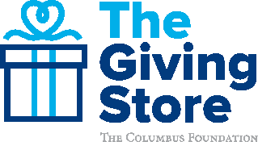
Directory Listings are a streamlined snapshot of your organization that tells your story.
With a free listing in The Giving Store, your organization benefits from easier access to donation details and increased visibility among potential donors. Registering for a listing only takes a few minutes, and provides your organization with a unique Giving Store link to share across multiple channels.
BENEFITS INCLUDE:
- Accept credit card, ApplePay, GooglePay, and PayPal gifts from anyone at any time by electronic deposit on a weekly basis
- Receive Donor Advised Fund grants from Foundation fund holders by electronic deposit and mail on a weekly basis
- Real-time view of donations before they are processed
- View and export donor acknowledgement details and special instructions for electronically deposited gifts
- A low processing fee* of 2.35%, with the option for donors to cover this at checkout so organizations receive 100% of donations
- Receive gifts through charitable gift card redemptions
- Participate in crowdfunding campaigns like Better Together and giving day events like The Big Give
- Attend in person and virtual capacity building workshops through the Nonprofit Forum
- Increased visibility to potential donors
- Promotional materials, graphics, and templates to market your organization’s listing
- A unique text code allowing donors to make an immediate donation from their smart phones
- A unique Giving Store link to share through your outreach efforts
- A link to your website so donors can learn more about your mission
- Links to your social media accounts so supporters can engage with your organization
Your organization is eligible to create a Directory Listing if it is a 501(c)(3) nonprofit organization that serves Delaware, Fairfield, Franklin, Hocking, Licking, Madison, Morrow, Perry, Pickaway, or Union counties.
*The Columbus Foundation does not benefit from these fees.
The Columbus Foundation 614/251-4000 columbusfoundation.org nonprofits@columbusfoundation.org

